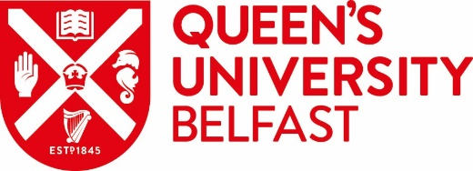

University Undergraduate Exchange Programmes 2019-20

Application Instructions

Thank you for your interest in taking part in one of the University's Exchange Programmes in 2019-20. Please note that the year or semester that you spend abroad will replace the year or semester you would have spent at Queen’s. It will not lengthen your degree programme and is not a year 'out'. The marks you achieve at your exchange university will be converted to Queen’s grades and will contribute towards your degree classification from Queen's University Belfast.

All documentation required for application can be downloaded from our website www.qub.ac.uk/exchangeprogrammes.

The notes on all three current schemes are available on the Careers website shown above. Please read them carefully. If more schemes become available, they will be added to the website.

The deadline for the submission of applications is 2.00 PM on FRIDAY, 08 FEBRUARY 2019. (NB Late applications will not be accepted.) Your application, which should be typed should comprise:

- a completed application form (available to download from www.qub.ac.uk/exchangeprogrammes. You should only complete the form once, indicating, in rank order, your preferred universities. You may indicate only one choice if you wish;

- your University Record to date (printed from your Queen’s Online account), listing the courses you have taken so far, or intend to take, at Queen’s and the grades achieved;

- a provisional list of courses at the exchange institution which you have ranked in first place. This should be drawn up in consultation with your Adviser of Studies, the International Adviser or the Director of Education in your School. Use the Course Selection Forms which are available to download for all three universities at www.qub.ac.uk/exchangeprogrammes.

(v) a reference from a member of academic staff at Queen's who can comment on your academic performance and abilities. In the case of Joint Honours, a reference from each subject area is required.

Remember to keep a copy of your application - you will be asked about it if you are selected for interview. Interviews are scheduled to take place on Wednesday 20 February 2019.

Global Opportunities Team
Careers, Employability and Skills
Student Guidance Centre
December 2018
(goglobal@qub.ac.uk)

